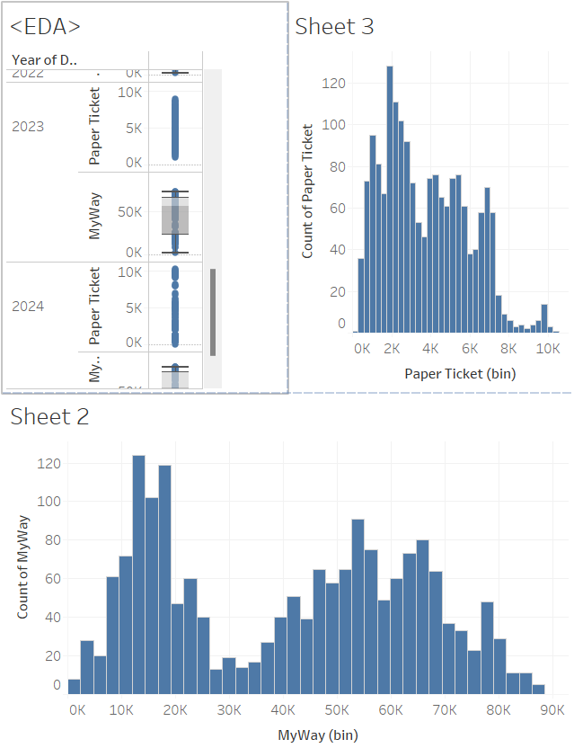

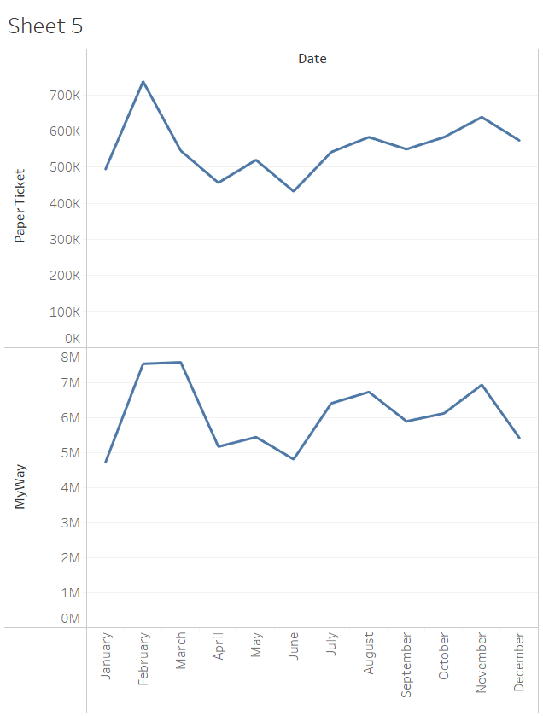

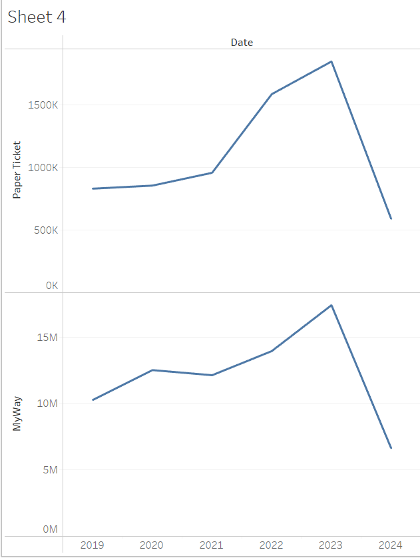

TASK 1 Insights :

1. The paper tickets in range of 2K to 3K has sold more than other ranges
2. The MyWay card is used in range of 12K-17K
3. The My way cards are the most used one
4. In the month of February most tickets were sold and the card being used around
5. The year 2023 has the most number people travelled by both the tickets and the myway card

TASK 2 INSIGHTS:

1. The Arima Model didn’t give accurate results and by finding the good hyper parameter manually we almost reduced the error rate.
2. So I used machine learning to predict the forecast
3. The model used in here is Random Forest which gave less Mean Squared error
4. The Date formatting was a complicated task while fitting into arima model
5. Mean Squared Error (MSE) for ARIMA: 624303012.7789506Mean Absolute Error (MAE) for ARIMA: 23574.233809533314

Which is very high

1. Random forest gave  
   Mean Squared Error (MSE): 2.183756817139993e-23Mean Absolute Error (MAE): 3.2741809263825417e-12